You are Invited to Join a Virtual Circle of Security® Hamden Parenting Workshop Series

Starts: Monday, October 18th







**What Is Circle of Security**®**?**

Parents want the very best for their children but sometimes it is hard to know how to help them.

Join us and explore:

* Ways to understand and support your child's feelings
* How to respond to your child's needs
* Experiencing more joy with your child
* Helping your child have high self-esteem, strong relationships and perform better in school

**Go** [**HERE**](https://www.youtube.com/watch?v=1wpz8m0BFM8) **to watch a short video about Circle of Security**

After you register, you will receive a packet of handouts and other relevant materials.

The ZOOM link will be sent to you and is the same link for all 8 sessions.

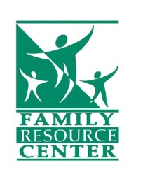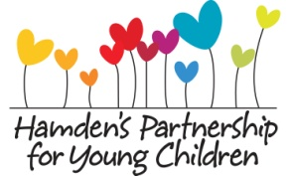

**Sign up: FREE 8 Sessions Circle of Security**® **Parenting Group**

**Mondays: October: 18, 25, November: 1, 8, 15, 22, 29 December: 6**

**6:00 pm-7:30 pm**

***Facilitator: Guadalupe Kuilan***

**To register: ssadinsky@hamdenyoungchildren.org or 203-407-7733**

**FREE Children’s Books and Giveaways!**