Keep in shape with your math this summer!

Just like conditioning for an athlete and practicing for a musician, math skills need to be maintained. You worked hard to make your gains this year. Don’t fall victim to the summer slide. We are happy to announce that your MobyMax.com account will remain activated throughout the summer. Complete at least 20 minutes each week to be prepared for the new school year. Continue as usual through July. Moby will be updating its site on August 1st. When you log in in August you will take the placement test and will then be able to continue to stay in shape with Moby for the new school year!
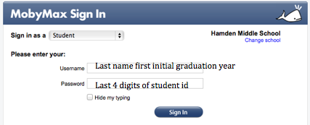
19
Internet and computer access
available at:

Miller Memorial Library
2901 Dixwell Ave., Hamden.

Whitneyville Branch Library
125 Carleton St., Hamden

Community Branch Library
91 Circular Ave., Hamden

