West Woods School 2019
Kindergarten Supply List
1 plastic pencil box | 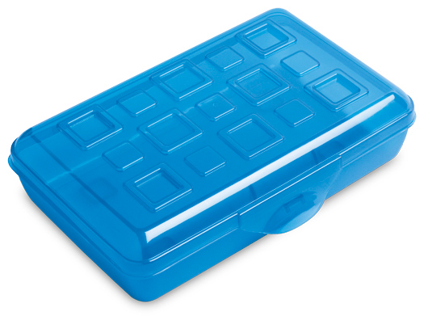
5 boxes of crayons (maximum 8 per box) | 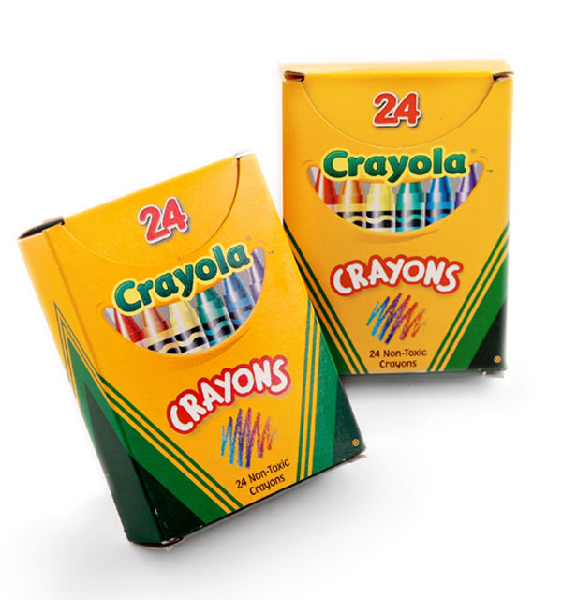
6 sharpened pencils with erasers | 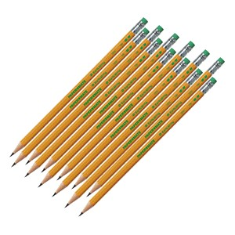
1 plastic 2-pocket folder | 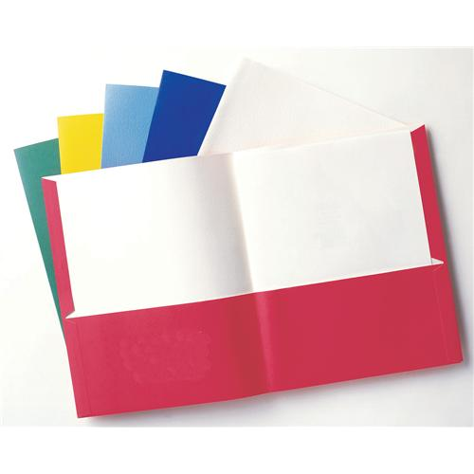
6 glue sticks ( not purple) | 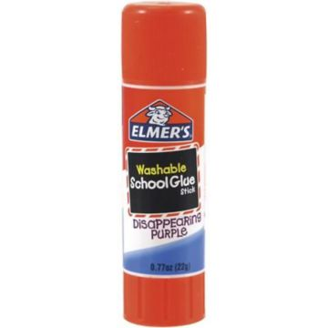
1 pair of headphones (no earbuds) | 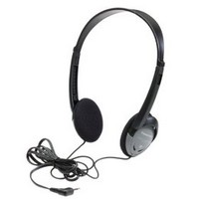
2 pads of 3x5 post-it notes | 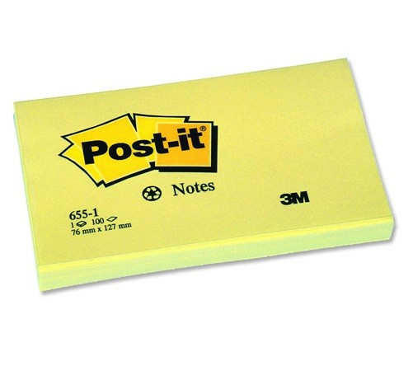
1 full size back pack ( no wheels ) | 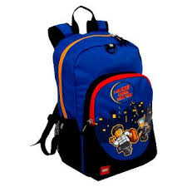
1 large beach towel | 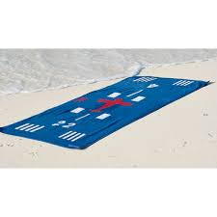

Please do not send in scissors, pencil sharpeners, colored pencils, markers, and pens. These tools will be provided at school when needed. Be sure to label all supplies with your child’s first and last name.
Grade 1 Supply List

1 plastic pencil box

3 boxes of crayons (maximum 24 per box)

12 sharpened pencils with erasers

1 plastic 2-pocket folder
8 glue sticks

1 pair of headphones (no earbuds)
1 dozen fine tip expo markers | 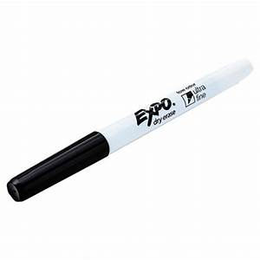

Please do not send in scissors, pencil sharpeners, colored pencils, markers, and pens. These tools will be provided at school when needed.
Be sure to label all supplies with your child’s first and last name.

Grade 2 Supply List

1 plastic pencil box | 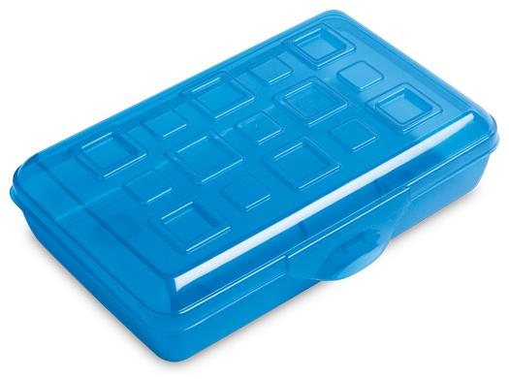
3 boxes of crayons (maximum 24 per box) | 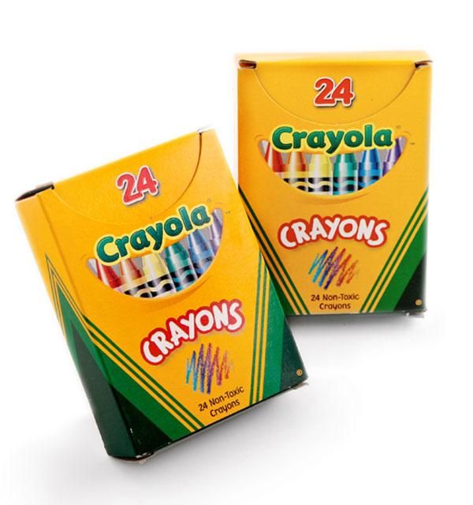
12 sharpened pencils with erasers | 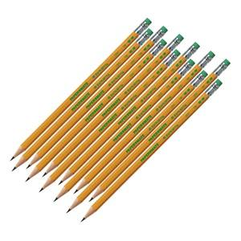
1 plastic folder with 2 pockets | 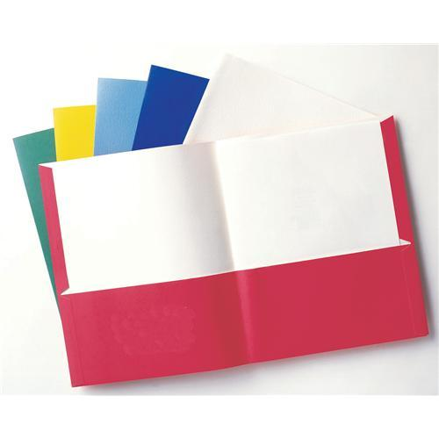
4 glue sticks | 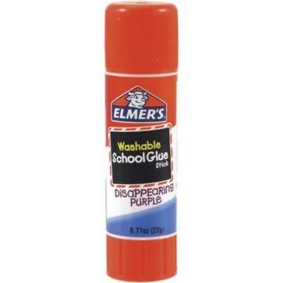
1 pair of headphones (no earbuds) | 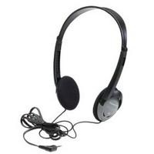
6 pads of 3x3 post-it notes | 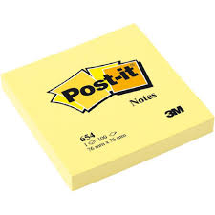
1 pair of scissors (Ms. Blake only) | 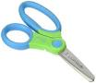
1 dozen fine point black dry erase markers | 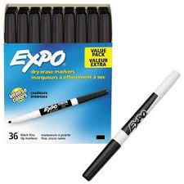

Please do not send in pencil sharpeners, colored pencils, markers, and pens. These tools will be provided at school when needed.

Be sure to label all supplies with your child’s first and last name.

Grade 3 Supply List

1 plastic pencil box

1 box of crayons (maximum 24 per box)

1 highlighter | 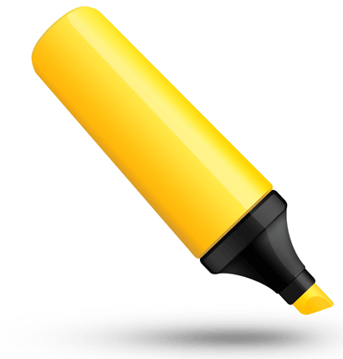
12 sharpened pencils with erasers

1 plastic pocket folder | 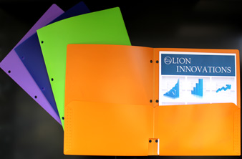
4 glue sticks

2 pack of 100 Post It Sticky Notes 3x3 | 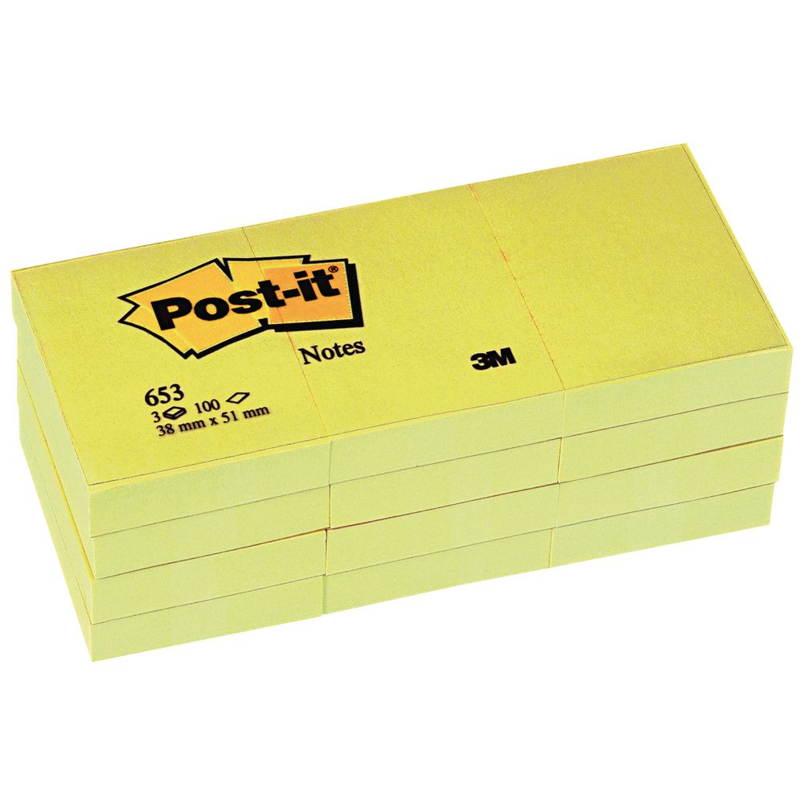
small headphones in a ziplock bag | 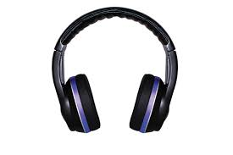

Please do not send in scissors, pencil sharpeners, colored pencils, markers, and pens. These tools will be provided at school when needed.

Be sure to label ALL supplies with your child’s first and last name.

Grade 4 Supply List

- 4 notebooks with the pages that tear out easily. Please label each notebook with one of these subjects: science/health, social studies, math, and spelling/vocabulary

- 6 plastic folders – one of each color (red, yellow, blue, green, white, and clear)

- 3 composition books

- a pencil box or bag -label with name

- 3 glue sticks

- 10 packages of Post-it Notes (3x 3 multicolored)

- 2 packages Post-it Notes (3 x 5 multicolored)

- 1 box of crayons / 1 box of colored pencils/ 1 box of thin markers

- 10 sharpened pencils with erasers

- Head phones or ear buds compatible with Mac and iPads

- Manual pencil sharpener

- Index cards (4 x 6 white lined)

- 3 yellow highlighters

Grade 5 Supply List

- Pencils (48)

- (No pens necessary)

- Post-It Notes (8 pads, name brand Post-Its preferred)

- Highlighters (4)

- Composition Notebooks (3)

- Three-Ring Binder 2” (1)

- Lined Paper, 3-hole punched (reinforced holes preferred) (1 pack)

- Pencil Pouch (1)

- Pocket Folder (this is our Home-School folder)

- Pack of Markers, 8 or more

- Pleasure Reading Book

Grade 6 Supply List

- 3 single spiral notebooks - Labeled SOCIAL STUDIES, SCIENCE, and MATH

- 3 dozen #2 pencils

- 1 box of colored pencils

- 1 box of colored markers

- 1 package of colored pens

- 1 package yellow highlighters

- 5 sturdy pocket folders- Labeled SOCIAL STUDIES, SCIENCE, READING, MATH, and HOMEWORK/NOTICES

- 2 composition notebooks- Labeled WRITING and READING

- 1 binder ( 1 inch)- Labeled WRITING

- Scissors

- Large zipper pouch to hold supplies

- Post-It Notes (package of 8)

- 1 package of 4 tabs or dividers for the binder

- 1 glue stick

